**CFG Foundation Degree Group Project**

**Group 5**

*What Have the Environmental Impacts Been From SpaceX Rocket Launches, and How Could SpaceX Minimise their Impact Moving Forward?*

**Contributors:**

Lana Britton

Tongtong Chen

Holly Feurtado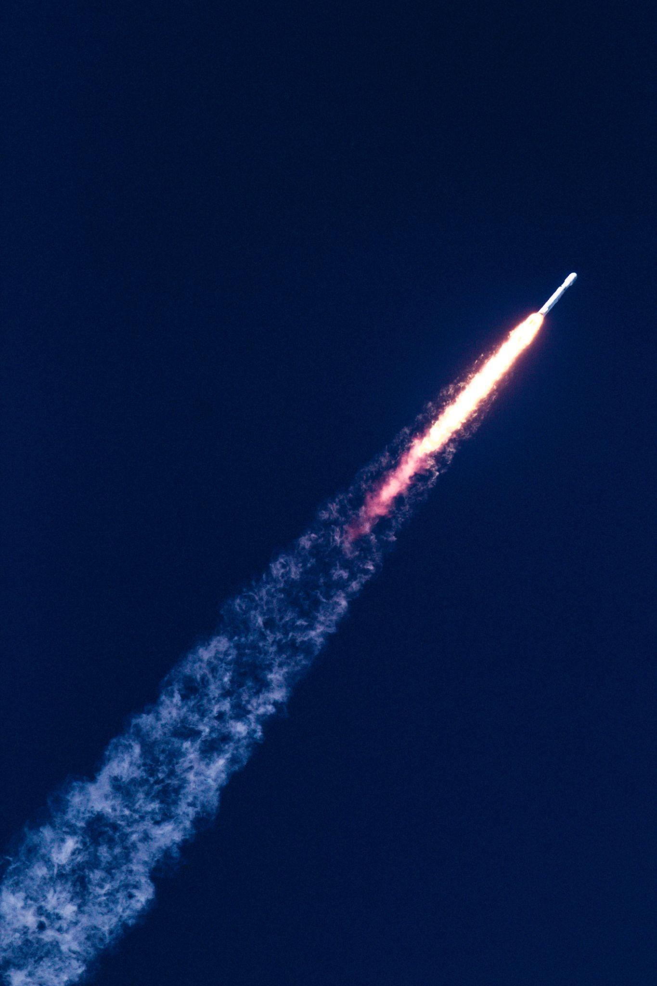

Yasmin Hassan

Abigail Kempson

Charlotte Thompson

### 

**Table of Contents**

**Introduction 3**

**Aims and Objectives 3**

Aim 3

Objectives 3

**Data Collection & Loading the Data 4**

Framing Questions 4

Data Gathering 4

Preprocessing 4

Exploratory Data Analysis 5

In-Depth Analysis 5

**Tools and Libraries 5**

**Implementation Process 6**

Achievements 6

Challenges 6

Decision to Change Something 6

**Agile Development 6**

**Result Reporting 6**

Subquestion A: Holly and Yasmin, How Do SpaceX Rocket Launches Compare Over Time in Terms of Environmental Impact? 7

Subquestion B: Abbi and Tongtong, What is SpaceX’s “Space Debris” Impact? 8

Subquestion C: Charlotte and Lana, How Do SpaceX Launches Compare with Other Countries/Locations and/or Companies in Terms of Environmental Impact? 9

Bonus Question: Predict the Amount of Space Debris in X Amount of Years Time 11

**Conclusion 11**

**Further work 12**

**Bibliography 13**

Subquestion A 13

Subquestion B 13

Subquestion C 13

Further work 14

**Appendices 15**

Appendix 1 - definitions 15

Appendix 2 - list of figures 16

# **Introduction**

Founded in 2002, SpaceX set out to be ambitious. They state to be advancing space exploration, making humanity a multi-planetary species, and ultimately ensuring the long-term survival of civilization. Elon Musk, SpaceX’s CEO, set out one of his main visions as creating Reusable Rocket Technology. Musk believes that reusability is crucial for reducing space travel costs and minimising its environmental impact. SpaceX has pioneered the development of reusable rocket technology, specifically the Falcon 9 and Falcon Heavy rockets. From this, their goal is to make space travel more accessible and economically viable by significantly lowering launch costs. This in turn triggered our curiosity into how SpaceX is achieving these goals and if data provides insights into these achievements.

In this report we aim to answer the question: What have the environmental impacts been from SpaceX rocket launches, and how could SpaceX minimise their impact moving forward? The report explains the process of how we addressed the question; from how we collected the data, worked as a team and then explaining the key insights from the data analysed. In carrying out this research, we have evaluated the environmental consequences of SpaceX's rocket launches and have added data-driven guidance for space organisations in adopting more sustainable practices and minimising their environmental footprint. While the report provides minimal visualisations due to constraints, please see a comprehensive list in our Final Project .ipynb file.

# **Aims and Objectives**

## Aim

1. To assess and understand the environmental impacts of SpaceX rocket launches and identify potential strategies for minimising their impact in the future.

## Objectives

1. To analyse the data and quantify the environmental impacts associated with SpaceX rocket launches, such as fuel emissions.
2. To compare SpaceX rocket launches with regard to fuel emissions, fuel types, and other relevant factors, in order to assess their environmental performance relative to other launch activities.
3. To investigate the decay impact of SpaceX rocket launches by studying the post-launch behaviour of rockets and assessing their potential for contributing to space debris.
4. To compare SpaceX rocket launches with those of other space organisations in terms of environmental impacts, efficiency, and other relevant parameters, in order to gain an understanding into industry-wide practices and potential areas for improvement.
5. As a bonus objective, to develop a machine learning model capable of predicting the amount of space debris in a given timeframe, which can provide an understanding into the long-term sustainability of space activities.

# **Data Collection & Loading the Data**

To collect the data, we utilised various sources such as space agency databases, official reports, and public datasets related to rocket launches and space exploration. We focused on obtaining data specifically related to SpaceX rocket launches, including details such as launch dates, rocket types, fuel types, and environmental impact metrics.

Here's how our team approached each key step of the data analysis process for that particular dataset:

## Framing Questions

Due to a joint interest in space exploration, our initial idea was to seek out public access datasets that we could use and guide us towards a question. We also all have an interest in sustainability or climate impact, so decided to take our research in that direction.

The topic of space exploration versus environmental impact was exceedingly vast and we wanted to narrow that down to be within the time frame of the topic, therefore through discussions as a team we decided to focus our question on one space company; SpaceX.

Subsequently, we decided to individually research which datasets we could find to use for a basic question - What are SpaceX’s environmental impacts? It was once we found these datasets that we were then able to refine and frame our questions, which we will lay out in the following section.

## Data Gathering

A few members of the team found a series of .csv files and APIs that we could use to answer the questions, some were more suitable than others.

We carefully reviewed the multiple datasets, both individually and as a team, the chosen datasets were provided by Abbi and identified the key aspects we wanted to explore.

* Space X API
* Rocket atmospheric impact - Emissions Inventory and Results CSV
* Space-Debris CSV (extracted from an API)

During a team meeting, we then formulated specific sub-questions to address the objectives of the analysis, and to help guide us to answer the main question.

## Preprocessing

We used the pandas library in Python to read the Excel files containing the datasets.

We extracted the relevant columns and performed extensive data cleaning to ensure the data was in a usable format, including:

* checking for NaN values
* dropping unwanted columns
* removing whitespace columns
* removed any trailing spaces in column names and standardised them for ease of analysis.
* creating a matrix to show the NaN values
* saving the clean dataset to a new .csv file

We grouped the data based on relevant variables, such as rocket type, company, or fuel type, to prepare it for further analysis.

## Exploratory Data Analysis

We conducted in depth exploratory analysis by creating over 15 visualisations, such as bar graphs, pie charts and scatter graphs, to understand patterns and relationships in the data. As mentioned above, all of these can be seen in our Final project .ipynb file. We utilised matplotlib, seaborn, numpy and pandas plotting functions to generate the visualisations. By using these techniques, we were able to gain a deeper understanding of the data and the environmental impacts of SpaceX’s rocket launches in comparison to other companies. We were able to use this information to make recommendations for how SpaceX can minimise their environmental impact moving forward.

## In-Depth Analysis

We performed additional in-depth analysis based on the questions and objectives defined earlier. For example:

* We looked at trends within SpaceX rocket launches in terms of fuel emissions;
* We looked at the amount of debris SpaceX had left from their rocket launches, the amount they were re-using (which was one of their key aims);
* We made comparisons with other companies based on the number of launches, the amount of CO2 emissions, and the type of rocket fuel used.

# **Tools and Libraries**

In our project, we used several libraries in a specific order to explore and analyse the data. Please see the README file in our Group Project .ipynb for an extensive list of libraries and why we used them .

1. **Pandas**
2. **Numpy**
3. **Matplotlib.pyplot**
4. **Seaborn**
5. **Requests**
6. **PPrint**
7. **Missingno**
8. **Sklearn.model_selection**
9. **Sklearn.linear_model**

# **Implementation Process**

Throughout the implementation process, our team faced various achievements, challenges, and made decisions to adapt and improve our work:

## Achievements

* Successful collaboration: Despite different opinions and knowledge levels, we were able to work together as a team and make progress on the project.
* Timely delivery: We adhered to agreed-upon timelines and completed a significant amount of work within the allocated time frame.
* Data analysis and visualisation: We successfully explored and analysed the data using appropriate tools and libraries, such as the ones mentioned above.

## Challenges

* Communication and understanding: Working in a group with diverse backgrounds and knowledge levels posed challenges in terms of effective communication and ensuring everyone understood the project requirements and objectives.
* Differences in opinions: Various perspectives within the team sometimes led to disagreements and delays in decision-making processes.
* Technical difficulties: Dealing with complex data and implementing advanced analyses required overcoming technical challenges and learning new concepts.

## Decision to Change Something

To address the challenges faced, we made a conscious decision to improve communication within the team. We scheduled regular meetings to discuss progress, clarify doubts, and ensure everyone was on the same page. We also allocated specific roles and responsibilities to team members based on their strengths and interests, allowing for more efficient work distribution and decision-making. In situations where there was a lack of understanding, we provided additional resources and conducted mini-workshops to enhance knowledge and skills in specific areas.

# **Agile Development**

Our team operated efficiently using a combination of Agile methodologies and Asana. Asana was suggested by Holly as this is a tool she currently uses and offered us to use her account. Therefore, we had a project management tool which ensured we prioritised tasks and tracked our progress. Asana ensured that everyone was on the same page which fostered a grounding of good communication and shared accountability. As for Agile, it formed the foundation of our team's approach to work and allowed us to be adaptable and collaborative. Through regular stand-up meetings, sprint planning and retrospectives, we embraced each other's proposals and worked as a team to meet projected milestones.

# **Result Reporting**

Our main focus was to answer the question: What are the environmental impacts of SpaceX rocket launches, and how can SpaceX reduce these impacts going forward? This question seeks to understand the environmental consequences of SpaceX's activities, aiming to discover the pollution they generate and propose ways for the company to minimise these effects in the future.

This question has been further split into three key subquestions and a bonus question; these are further explained and answered below.

## Subquestion A: Holly and Yasmin, How Do SpaceX Rocket Launches Compare Over Time in Terms of Environmental Impact?

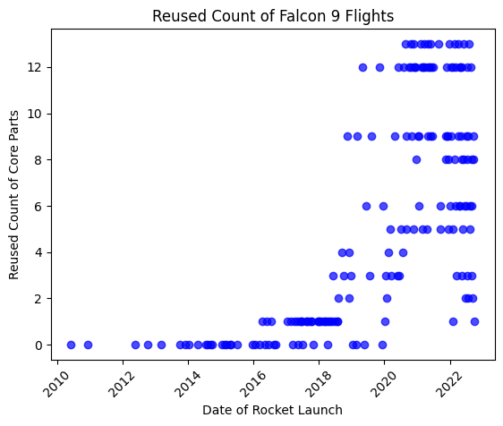In order to understand the environmental impact of SpaceX rocket launches over time, we specifically looked at two key factors in our data; fuel emissions from 2019 launches and the reusability of core rocket parts since 2010 and the inception of SpaceX’s first rocket; Falcon 1. What we mean by reusable rocket technology is the ability for SpaceX to reuse core engine parts for multiple flights and launches, which is key in their mission to Mars and also to reduce their environmental impact. As per Figure 1: Total Number of Flights Per Core Part, the reusability factor of core engine parts has increased 1200% since the Falcon 1 launch, enabling the Falcon 9 engine to be reused multiple times. Figure 2: Reused Count of Falcon 9 Flights, further supports this, demonstrating a significant increase in reusability over time, especially since 2018. Therefore, SpaceX’s ability to reuse core rocket parts on flights has increased over time and with each new rocket version - Falcon 1, Falcon Heavy, Falcon 9 through systematic technological and design improvements to their rockets.

*Figure 1*

*Figure 2*

In terms of SpaceX rocket fuel emissions, in 2019, the total fuel emissions (CO₂ ) remained the same for each rocket launch of the same rocket type. Additionally, the Falcon Heavy rocket emits significantly more CO₂ than the Falcon 9 (approx 2.5 million Kgs more). However, this is to be expected given the mass of the Falcon Heavy rocket.

## Subquestion B: Abbi and Tongtong, What is SpaceX’s “Space Debris” Impact?

We started by looking at the overall data to see how much space debris had been created over time. Figure 3 shows the amount of Space Debris created over time by all companies within the space decay data frame. It shows that until the early 1990's, a time-period of 30 years, there was a fairly stable and slow accumulation of space debris, from 0 to 2000 objects. Then after this period there is an exponential increase from 2000 objects to over 14,000 objects in a space of 30 years, an increase of 600%.

Next, in order to answer our question and to learn about Space X's decay impact, we must understand what the different pieces of space debris are and what they mean in terms of environmental impact.

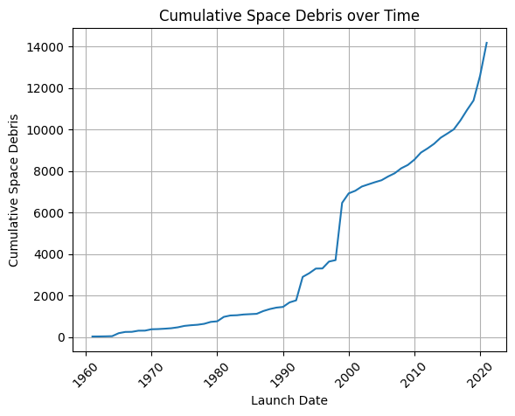Figure 4 depicts the proportions of the different types of space debris. It shows that the majority, 59.3%, is unwanted debris with 35.4% consisting of known payloads such as satellites and only 5.3% as known and factored in rocket parts which will be rendered.

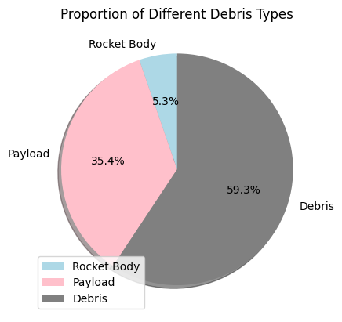We also looked at Space X's impact on the number of pieces of space debris compared to randomly selected companies, Nasa, CASC and ULA. In comparison to CASC and ULA, SpaceX has made a very minimal contribution since its establishment in 2006 but still more than its American counterpart NASA. Space X has accumulated around 40 pieces of debris compared to CASC's 550 and ULA's 250. However, this is still around 500% more than NASA's 5. Although SpaceX has not accumulated much compared to other companies, there are still around 14 pieces, which is unwanted decaying debris. This debris cannot be reused or taken away and must be left for it to re-enter the atmosphere or decay on its own. This is compared to the rocket bodies, with a count of around 24. These are known pieces, intentionally put there, and can be called back by Space X in a hope of being reused. Finally, there are zero payload pieces of debris (which are usually satellites).

*Figure 4*

*Figure 3*

As SpaceX continues to develop it is obvious from the data they are learning from each launch and other companies around them. This is shown through the fact that, although they have created debris, they have made very little in comparison to many of their counterparts mainly due to SpaceX’s booster reusability technology. Elon Musk talks a lot in the media about how he is trying to create a company which works alongside the environment and reuse what they create to stop the abundant amount of waste and to make rocket launch more affordable. This is shown in the data as, especially compared to ULA and CASC, SpaceX has very little debris in the Earth’s atmosphere.

## Subquestion C: Charlotte and Lana, How Do SpaceX Launches Compare with Other Countries/Locations and/or Companies in Terms of Environmental Impact?

To answer this question, our analysis focused on the different fuel types used in rocket launches and the emission factors from these fuels. It is important to note that we are not analysing the emissions impact of individual rocket launches, but assessing the overall environmental impact of SpaceX as a company in 2019. Therefore, when comparing the company's total emissions impact, the number of launches conducted is not a primary concern.

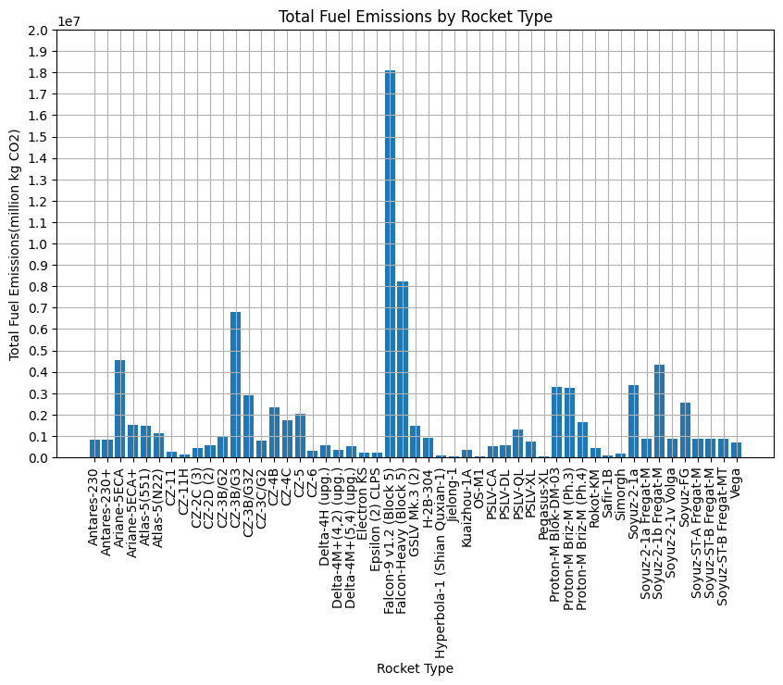These emission factors provide a standardised measure to estimate the amount of carbon dioxide emissions associated with their corresponding rocket fuel. The data we looked at was from 2019, so provides just a snapshot at SpaceX’s rocket launch information. We know that Kerosene rocket fuel emits the most CO₂ emissions at over 3 kg of CO₂ per kg, with hydrogen liquid rocket fuel emitting less than 1kg of CO₂ per kg.

*Figure 5*

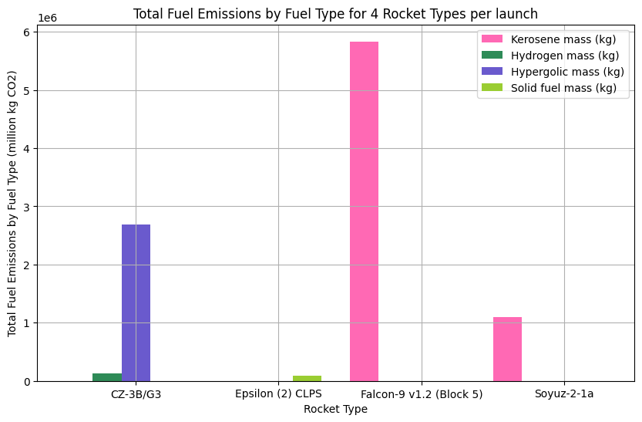As you can see in Fig.5, in 2019, the rocket that had the highest total fuel emissions was the ‘Falcon-9 v1.2’, and the rocket with the second highest total fuel emissions was the ‘Falcon-Heavy’, which are both rockets that have been designed and manufactured by SpaceX. In Fig.5 there is a vast difference in total fuel emissions between the top 2 highest and the lowest 20 total fuel emissions.

*Figure 6*

However, this graph does not take into consideration the number of launches the rocket has made, just the total amount of emissions. Therefore, to answer our question more completely, we started to look more closely at the number of rocket launches per company to see if the emissions (and hence the environmental impact) were comparable.

Please look at our final project Notebook for a full range of graphs and plots. We found that the China Aerospace Science and Technology Corporation (CASC) has the highest number of launches by 20 launches. We thought this would be the most interesting company to compare with SpaceX launches. To analyse further why SpaceX Rockets have the highest emissions in 2019, we needed to look at the rocket fuel types for the launches. To do this we looked at the emissions from rockets from 4 different companies; Falcon 9 from Space X (11 launches) , Epsilon (2) CLPS from NASA (1 launch), CZ-3B/G3 from China Aerospace Science and Technology Corporation (CASC) (7 launches) and Soyuz-2-1a from Russian Space Forces (RAF) (4 launches). In Fig.6, you can see the total CO₂ emissions by fuel type for each Rocket. Fig.6 showed us that in each individual launch, Kerosene produced the most CO₂ missions (just under 6 million kg compared with less than 3 million kg of CO₂ for Hydrogen fuel, Hypergolic Fuel and Solid Fuel mass).

To answer our question; how does SpaceX compare with other companies? In total in 2019, SpaceX has had 13 launches, with a total of over 26 million kg of CO₂ emissions. CASC has had 33 rocket launches with only 20 million kg of CO₂ emissions - this is over double the amount of rocket launches, and half the amount of CO₂ emissions. In our exploratory analysis, although SpaceX pride themselves on the reusability of the elements in their spacecraft, as they do wish to minimise their environmental impact, looking at their CO₂ emissions from their preferred fuel type for rocket launches would be a good place to start.

## Bonus Question: Predict the Amount of Space Debris in X Amount of Years Time

Originally, we posed the question of predicting the amount of space debris in the future, however we didn’t manage to get that far. We started to focus on developing a model to predict the type of space objects with the intent to move onto our original question. We began by visualising the increase of debris over time using a line plot; this was achieved by grouping the Launch Date data and calculating the cumulative space objects over time. Subsequently, we then started to think about the ML model using the plot as a guide. We prepared the data by creating dummy variables as the model cannot have strings as inputs, and splitting it into training and testing data. We decided to do a Logistic Regression model, and after fitting the model on the training data (80% of the original data set), we tested the model using the remaining 20%.

The model was able to predict the type of object by looking at the launch date and learn that different types of objects are more likely to be launched on different dates. However, when we printed the accuracy of the model, which was only 60%. We believe it to be this low due to the small amount of data inputted into the model in the first place. To improve on the model, we would need a larger dataset so it could learn about the relationship between the launch date and the object. The model could also be improved by using more features; for example, if the model was trained on the weight of the object, or the county that launched the object as well, it would be able to make more accurate predictions. At present, it is a very basic model that could be improved.

# **Conclusion**

Our analysis of SpaceX's environmental impact compared to other space agencies and companies has revealed both progressive steps and areas for improvement. We found that SpaceX's rocket launches have largely similar fuel emissions over time. The Falcon Heavy rocket has shown that it emits more than its Falcon 9 counterpart. However, SpaceX has been improving its ability to reuse core parts of its rockets over time, therefore limiting their environmental footprint.

In terms of space debris, SpaceX has created a relatively minimal amount of debris since its establishment, particularly compared to China's CASC and America's ULA. It is worth noting, however, that the amount of debris created by SpaceX is still greater than NASA's. SpaceX's focus appears to be on reducing the creation of unwanted decaying debris, aligning with Elon Musk's stated goal of reducing environmental harm.

Comparing SpaceX's fuel emissions to those of other companies, SpaceX was found to be one of the higher contributors. This is largely due to SpaceX's exclusive use of kerosene fuel, which produces significantly more CO₂ emissions than the hydrogen and hypergolic fuels used by other entities. Despite having fewer launches than CASC, SpaceX has produced more total CO₂ emissions.

In conclusion, SpaceX has made significant changes in reducing its environmental impact through the reuse of core rocket parts and a smaller contribution to space debris compared to other companies. However, their high fuel emissions, primarily due to the use of kerosene fuel, remain a concern. We recommend SpaceX continue exploring innovative ways to reduce their environmental impact, potentially through a diversified fuel strategy or further efforts in rocket part reuse.

# **Further work**

Upon further investigation, we discovered SpaceX have already started developing their next generation rocket engine - Raptor Engine, to power its new reusable spacecrafts and rockets. Raptor Engine will use a combination of liquid oxygen and methane instead of the traditional kerosene, as methane prevents a build-up of deposits in the engine and is more cheaply available.

However, it seems that the real economic reasons for driving the development of Raptor Engine is the engine’s more superior reusability rather than the more efficient fuel it employs. For a typical liquid rocket, the cost of propellant is normally less than 1% of the total launch costs. Therefore, the reusability of a rocket (inversely related to how many rockets are left in space) is a more significant indicator of the environmental impact of the rocket launches.

In terms of understanding the impact of greenhouse emissions from rocket launches, a better comparison study may be looking at the rocket industry versus another heavy emitting industry, for example the aviation industry, to analyse how greenhouse emissions have changed over time.

# **Bibliography**

European Space Agency. 2017. The environmental impact of rocket launches. Available from: <https://www.esa.int/About_Us/Environment/The_environmental_impact_of_rocket_launches>

National Aeronautics and Space Administration. 2016. Environmental impact statement for

National Park Service. 2021. Rocket Launch Noise and Wildlife. Available from: <https://www.nps.gov/articles/rocket-launch-noise-and-wildlife.htm>

SpaceX. 2022. Reusable Rockets. Available from: <https://www.spacex.com/reusability/>

SpaceX Falcon 9 and Falcon Heavy launch vehicles. Available from: <https://www.nasa.gov/sites/default/files/atoms/files/falcon9_falconheavy_eis_executive_summary.pdf>

Tesla. 2021. Our Energy Products. Available from: <https://www.tesla.com/energy>

United States Environmental Protection Agency. 2021. Air Pollution from the Aerospace Industry. Available from: <https://www.epa.gov/stationary-sources-air-pollution/aerospace-industry>

## Subquestion A

Harfield, J. 2021. How Do Rockets Land Back on Earth [Online]. Available from: <https://www.makeuseof.com/how-do-rockets-land-back-on-earth-the-amazing-tech-involved/> [Accessed 11 May 2023]

RandRed, 2021, “5 Most Important Parts Of A Rocket” [Online]. Available from: <https://www.rankred.com/parts-of-a-rocket/>

## Subquestion B

Drishtiias, 2020. Types of Orbit [Online]. Available from: <https://www.drishtiias.com/to-the-points/paper3/types-of-orbit#:~:text=Molniya%20orbit%20offers%20a%20useful,of%20view%20of%20geostationary%20satellites> [Accessed 20 May 2023].

Garcia, M., 2021. Space Debris and Human Spacecraft [Online]. Nasa. Available from: <https://www.nasa.gov/mission_pages/station/news/orbital_debris.html> [Accessed 20 May 2023].

Iberdrola, 2023. Space debris: is it time to start taking care of the cosmos? [Online]. Available from <https://www.iberdrola.com/sustainability/space-debris> [Accessed 21 May 2023].

Space-track.org, 2023. Available from: <https://www.space-track.org/auth/login> [Accessed 20 May 2023].

SpaceX, 2023. Available from: <https://www.spacex.com/> [Accessed 14 May 2023].

## Subquestion C

ChemEurope.com Encyclopedia, “RP-1”. Available from: <https://www.chemeurope.com/en/encyclopedia/RP-1.html>

ChemEurope.com Encyclopedia, "Rocket Propellant". Available from:

<https://www.chemeurope.com/en/encyclopedia/Rocket_propellant.html>

Headed for Space, “Using Liquid Hydrogen as Rocket Fuel”. Available from:<https://headedforspace.com/using-liquid-hydrogen-as-rocket-fuel/>

Headed for Space, "Using Hypergolic Rocket Fuel" . Available from:

<https://headedforspace.com/using-hypergolic-rocket-fuel/>

Headed for Space, “Using RP-1 as Rocket Fuel”. Available from: <https://headedforspace.com/using-rp1-as-rocket-fuel/>

MasterClass, "What Are the Different Types of Rocket Fuel? Learn About Solid and Liquid Rocket Fuel and How Rocket Fuel Has Changed Over Time". Available from:

<https://www.masterclass.com/articles/what-are-the-different-types-of-rocket-fuel-learn-about-solid-and-liquid-rocket-fuel-and-how-rocket-fuel-has-changed-over-time>

NASA Glenn Research Center, "Rocket Propulsion" ). Available from:

<https://www.grc.nasa.gov/www/k-12/airplane/srockth.html>

NASA, “Hydrogen: The Fuel of Choice”. Available from <https://www.nasa.gov/topics/technology/hydrogen/hydrogen_fuel_of_choice.html>

Robert A. Braeunig, Rocket and Space Technology. “Rocket Propellants”. Available from: <http://www.braeunig.us/space/propel.htm>

## Further work

O’ Callaghan J., 2019. The wild physics of Elon Musk's methane-guzzling super-rocket [Online]. Wired. Available from: <https://www.wired.co.uk/article/spacex-raptor-engine-starship> [Accessed 26 May 2023].

# **Appendices**

## Appendix 1 - definitions

**Cores** - a core in terms of a rocket launch refers to the central structure of a rocket's main engine - it can be multiple cores. In the case of a reusable core, it includes not only the main engine, but also additional equipment such as landing legs, guidance systems, and parachutes.

**Debris** - Debris, also known as space debris or space junk, refers to man-made objects in space that are no longer functional or serve any purpose. Debris can include fragments from rocket launches, old satellites, spent rocket stages, discarded equipment, and other objects that remain in orbit. The distinction between "rocket body" and "debris" is based on the original intent and function of the object. Rocket bodies are the intentional components of a launch vehicle, whereas debris consists of non-functional or discarded objects in space.

**Hydrogen fuel** - is a type of gas (H2) that is used as a propellant for rocket engines. It is often used in combination with liquid oxygen (LOX) as an oxidizer in a rocket engine's combustion process.

**Hypergolic fuel** - is a type of rocket propellant that ignites spontaneously upon contact with another component, known as the oxidizer, without the need for an ignition source like a spark or flame.

**Kerosene** - is a type of rocket fuel; it is used in liquid fueled rocket engines. It is a refined form of kerosene fuel that has been purified and processed to meet the requirements for rocket propulsion (i.e. the process of expelling fuel to propel a rocket into space).

**Launchpad** - The facility where the rocket is launched from.

**Payload** - a payload in terms of a rocket launch is any cargo/equipment that is carried by a rocket and intended to be deployed in space or delivered to a specific destination.

**Rocket Body** - A rocket body refers to the main component of a launch vehicle or a rocket that was intentionally placed into orbit to deliver a payload, such as a satellite or spacecraft, into space.

**Solid fuel mass** - refers to a type of propellant that is in a solid state. It typically consists of a mixture of fuel and oxidizer components, compressed together into a solid form.

## Appendix 2 - list of figures

**Figure 1:** *Total Number of Flights Per Core Part*

**Figure 2:** *Reused Count of Falcon 9 Flights*

**Figure 3:** *Cumulative Space Debris over Time*

**Figure 4:** *Proportion of Different Debris Types*

**Figure 5:** *Total Fuel Emissions by Rocket Type*

**Figure 6:** *Total Fuel Emissions by Fuel Type for 4 Rocket Types per launch*